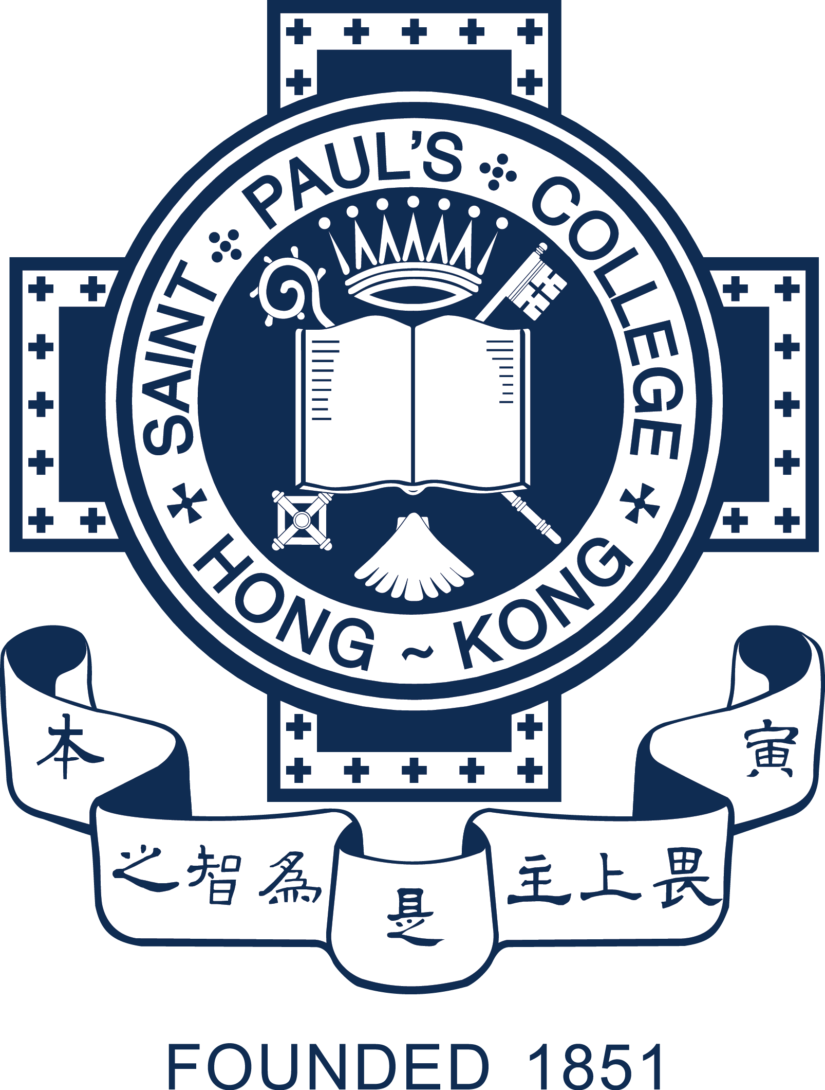

St. Paul’s College Foundation Limited
Annual General Meeting
27th April, 2021

Chairman’s Report
Dr. Cheng Cheuk Sang

Social distancing made 2020 a challenging year for all and the Foundation was no exception. Planned activities had to be called off, making it very difficult, if not impossible, to bring together parents, alumni and friends of St. Paul’s College for reunions and special events; nor were there occasions to explain our development plans and appeal for support. It is my honour to have a hardworking team to keep the Foundation active in maintaining contact with the St. Paul’s College family and make plans for the upcoming Anniversary celebrations. I must also congratulate the Fundraising Committee for the tireless effort in raising funds for both the School Enhancement Project and the newly established Endowment Fund.

After the completion of Phase One of the School Enhancement Project, the Foundation continued to make every effort to pave the way for the subsequent phases and other projects. Our Fundraising Committee has achieved encouraging results. So far, about half of the funds required for Phase Two have already been pledged. At the end of 2020, we were also given the green light for the construction of the indoor swimming pool and the relocation of the main entrance. The second phase will create space for the reshuffling of the school office, the library and hopefully the staff rooms to achieve better connectivity of functions and facilities on the school campus.

Through the initiative of the fundraising committee, graduates from different years have been pooling funds in support of the College. The newly established Endowment Fund is now on track, thanks to the anonymous alumnus who pledged to donate a matching fund of up to $30 million, which will allow the College to cater for students from more diverse backgrounds.

The restructuring of the Foundation is well underway and we can be assured of better security of donor information and more transparency in the management of the funds. We are thankful to our donors for their unwavering support and the trust they have placed in us. With the funds

/….P.2

- 2 -

raised, we support the College when need arises. For example, we have provided the funds needed for the birthday books scheme of the Principal for the juniors to encourage reading. We have supported our sports teams and hope to enhance team spirit through the sponsorship of team jerseys. Also, we have provided financial support for the solar panel project, which aims to cultivate students’ awareness of the importance of conservation of natural resources among our students.

To reduce the use of disposable face masks, we have also received a donation from an alumnus for the making of cloth face masks coated with “Ensure Guard” which gives the masks a much longer life span. The 100% natural disinfectant will be effective for 30 washes. The masks can be treated with the spray again to lengthen its life span by another 30 washes. The Foundation has decided to offer free treatments of the cloth face masks on request. One face mask will be given to donors of HK$500 and above.

The Foundation and its Executive Committee members will work together to make sure that all funds raised will be allocated through the proper channels and for designated purposes. I am thankful to all members for their support and advice. Let us work together to ensure that the second phase of the School Enhancement Project will come to fruition. I sincerely hope that 2021 brings new hopes and promises and that the SPC family will be able to get together more often, especially for the celebration of the 170th anniversary of the College.

